BaysideCEU Audit IQ
Startup & How-to Guide

Welcome to BaysideCEU
BaysideCEU’s Audit IQ system is designed to help facilities automatically track their employees’ compliance. Once your Facility has set up Audit IQ, you will be able to see when an employee last took mandated trainings, when they will next need to take their trainings, and have employees automatically notified when they are required to take a training.
This guide will walk you through the full functionality of the Audit IQ system by BaysideCEU from start to finish so you know exactly how to use the system efficiently, greatly reducing your compliance-related workload.
By the end of this guide, you will know how to:
- Create and Edit Roles to divide staff by training requirements
- Assign Employees to Roles so they take the correct coursework
- Setup Course Schedules to track course completions and due dates (automatic notifications)

Guide Overview
This guide is divided into sections so you can reference each section based on your needs
- Group Management Dashboard – Accessing the Group Management Dashboard from a Group Leader account
- Creating and Editing Roles – Assigning courses into roles to divide employees based on their mandated requirements

- Assigning Employees to Roles – Assign employees to the previously created roles for course scheduling and course organization purposes

- Course Scheduling – Setup course scheduling based on Role or Individual User to track course completions and due dates.

- Compliance Tracking – View real-time progress, check course completion status, and identifying overdue trainings.

Group Management Dashboard
The Group Management Dashboard is your central hub for all facility training activities. It is only accessible through Group Leader accounts.

Step 1 – Create Group Leader Accounts (IF YOU DO NOT HAVE A GROUP LEADER ACCOUNT)
- Any staff responsible for managing employee training in BaysideCEU should have a Group Leader account.

  - Create a BaysideCEU account.
  - Existing Group Leaders can invite other employees to be Group Leaders (or)
  - Provide BaysideCEU with the account details of the staff who should be Group Leaders.

Step 2 – Access the Group Management Dashboard
- Log in to your Group Leader account.
- On your main dashboard, you will see a Manage button next to your facility name if you have Group Leader access.
- Click Group Management in the top-right menu to enter the dashboard.
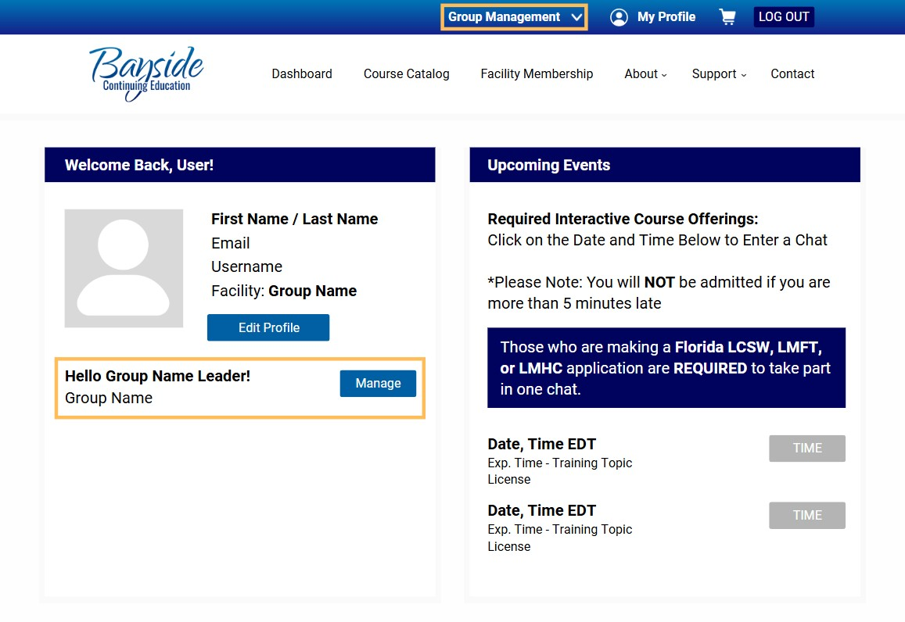

Creating and Editing Roles
Before you begin scheduling any coursework, first you must assign the coursework to your employees. There are 2 ways to achieve this:

Option 1 – Assign Courses by Role
- From the Group Management Dashboard menu, select Edit Roles.
- Enter the name of the role (e.g., “Counselor,” “Nurse,” “Direct Care Staff”).
- Search for and select courses for that role.
- Click Save Changes.
The roles appear as drop-down menus containing all assigned courses. This is accessible under each enrolled user’s Dashboard tab with the name Group Name Assigned Courses.

Option 2 – Assign Courses to an Individual
- From the Group Management Dashboard menu, select Individual Course Assignment.
- Enter the employee’s name in the Select a User field.
- Search for and select the courses you want to assign.
Click Save Changes.
Courses assigned by Individual Course Assignment will only appear for the employee who was assigned the coursework. They will display under the Group Name Assigned Courses tab.

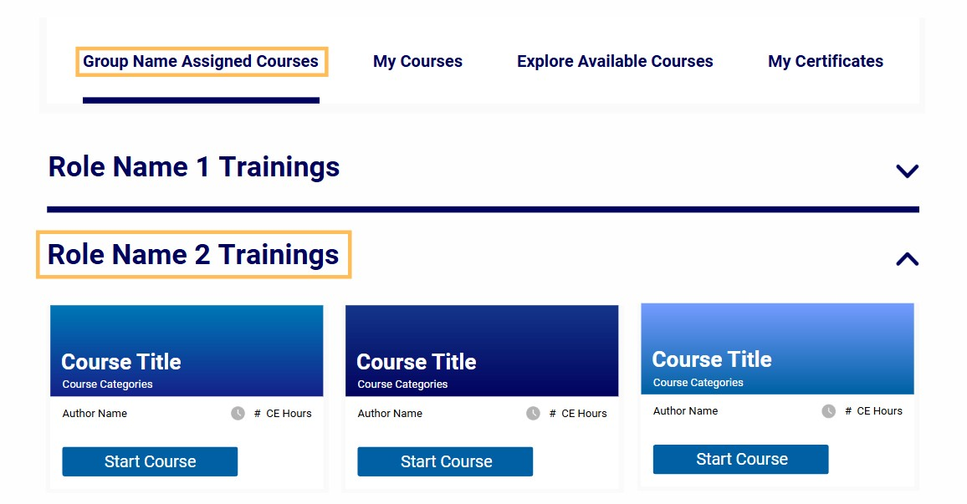

Assigning Employees to Roles
The final step before creating Course Schedules is to assign Employees to their Roles. This way they are assigned courses that match their mandated requirements.

Step 1 – Click Group Management using the Group Management Menu
This will bring you to your Employee Roster, which displays a table of valuable information regarding each Enrolled User. The very far-right of the table displays their assigned Role.

Step 2 – Click the Manage Drop-Down Menu (May display as Users)

Step 3 – Select Bulk Role Edit
In this menu, use the Select Members and Select Roles menus to assign your employees to a role. For example, Employee 1 & 2 are Nurses, Employee 3 & 4 are Counselors.

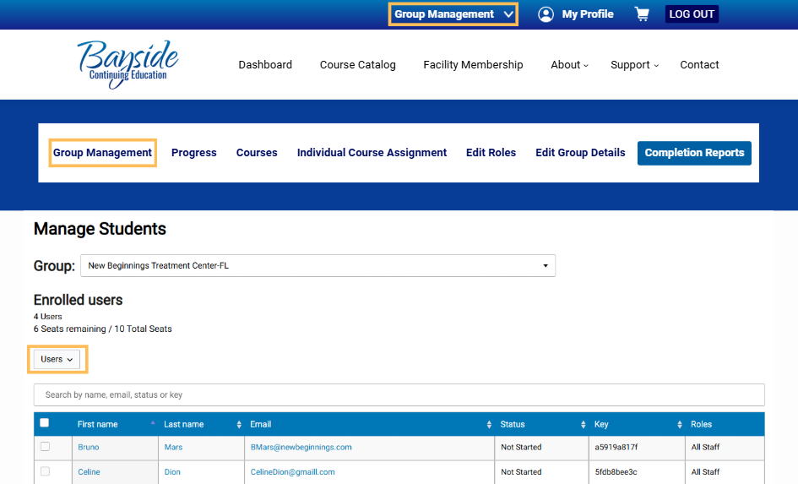

Course Scheduling

Step 1 – Click Course Schedule using the Group Management Menu
The Course Schedule menu is where you will be able to set up Rules, which are customizable tracking parameters you can use to track coursework based on Roles or Individual Employees.
There are two ways to setup Rules:

Option 1 – Rule Type: By Role
This option is to assign coursework based on mandated requirements for a role.
For example, Counselors are required to take Aggression Control yearly. Rule Type: By Role allows you to create a Course Schedule for Aggression Control for all of your employees who are assigned to the Counselor Role, activating tracking for when their last individual completion was, when their next completions are due, and automatic notifications to each individual.

Option 2 – Rule Type: By Individual
This option follows the same functionality but is instead assigned by Individual instead of Role. Allowing you to divide certain coursework to employees based on individual requirements.

Step 2 – Input Rule Parameters
- Rule Name: The name or label of the Course Schedule (Ex. Counselor Yearly)
- Rule Type: How the Rule applies (By Role or By Individual)

Step 3 – Assign Coursework and Occurrence
Click Add Course and select any number of trainings to assign to the individual or role.
From there, set how often the course is required to be completed by mandates (Ex. Yearly). And finally, select how many days before the due date you would like your employee to be notified via email.

(All Group Leaders can also be notified of upcoming due dates under Edit Group Details)

Step 4 – Click Add Rule to Finalize Course Schedules

Compliance Tracking

Step 1 – Click Compliance using the Group Management Menu
This is where all existing Course Schedules will be displayed. This menu allows you to view that an employee is fully compliant, when they have a training due, and finally if an employee is non-compliant due to a missing training.

There are 3 existing Course Status:
- Compliant – The employee is up to date on this training
- Due Soon – The employee is due for this training based on your set parameters
- Overdue – The employee is non-compliant and has not taken this training

That’s It!
Important Note: Employees will still have access to all coursework they wish to take through Explore Courses. This is a tracking tool, not a course access tool.
We hope you find BaysideCEU’s Audit IQ system valuable in simplifying your compliance processes and supporting your team’s training needs. If you ever have questions or need assistance, our support team is here to help. Thank you for trusting BaysideCEU!

