BaysideCEU Facility Membership
Startup Guide

Welcome to BaysideCEU
We are excited to provide your facility with a comprehensive training management system designed to make compliance easier, faster, and more reliable.
This guide will walk you through the full functionality of your BaysideCEU Facility Membership — from onboarding staff and assigning courses to tracking progress, verifying completions, and printing certificates.
By the end of this guide, you will know how to:
- Set up your staff quickly and accurately
- Assign the right training to the right people
- Monitor course progress in real time
- Generate and print completion certificates
Our goal is to ensure you can confidently use every tool available to keep your facility’s training organized, efficient, and fully compliant.

Guide Overview
This guide is divided into sections so you can quickly find what you need — whether you’re setting up your facility for the first time or managing ongoing training.
- Getting Started – Activating your facility group, creating Group Leader accounts, and accessing the Group Management Dashboard.

- Onboarding Employees – Adding users, managing the Employee Roster, and helping staff enroll in courses.

- Assigning Courses and Roles – Creating roles, assigning courses by role or individual, and understanding where employees take their courses.

- Tracking Progress & Completions – Viewing real-time progress, checking course completion status, and identifying overdue training. As well as Printing and downloading certificates and generating compliance reports.

- Account Settings & Support – Updating facility information and accessing help and resources.

Getting Started
The Group Management Dashboard is your central hub for all facility training activity. It is only accessible through Group Leader accounts.
Step 1 – Activate Your Facility Group Account
1. Pay the invoice sent to your email to begin your Facility Membership.

Step 2 – Create Group Leader Accounts
- Any staff responsible for managing employee training in BaysideCEU should have a Group Leader account.
- Group Leaders can add additional Group Leaders once the Facility Group is active.
- To assign Group Leader access:

  - Log in or create a BaysideCEU account.
  - Provide BaysideCEU with the account details of the staff who should be Group Leaders.

Step 3 – Access the Group Management Dashboard
- Log in to your Group Leader account.
- On your main dashboard, you will see a Manage button next to your facility name if you have Group Leader access.
- Click Group Management in the top-right menu to enter the dashboard.
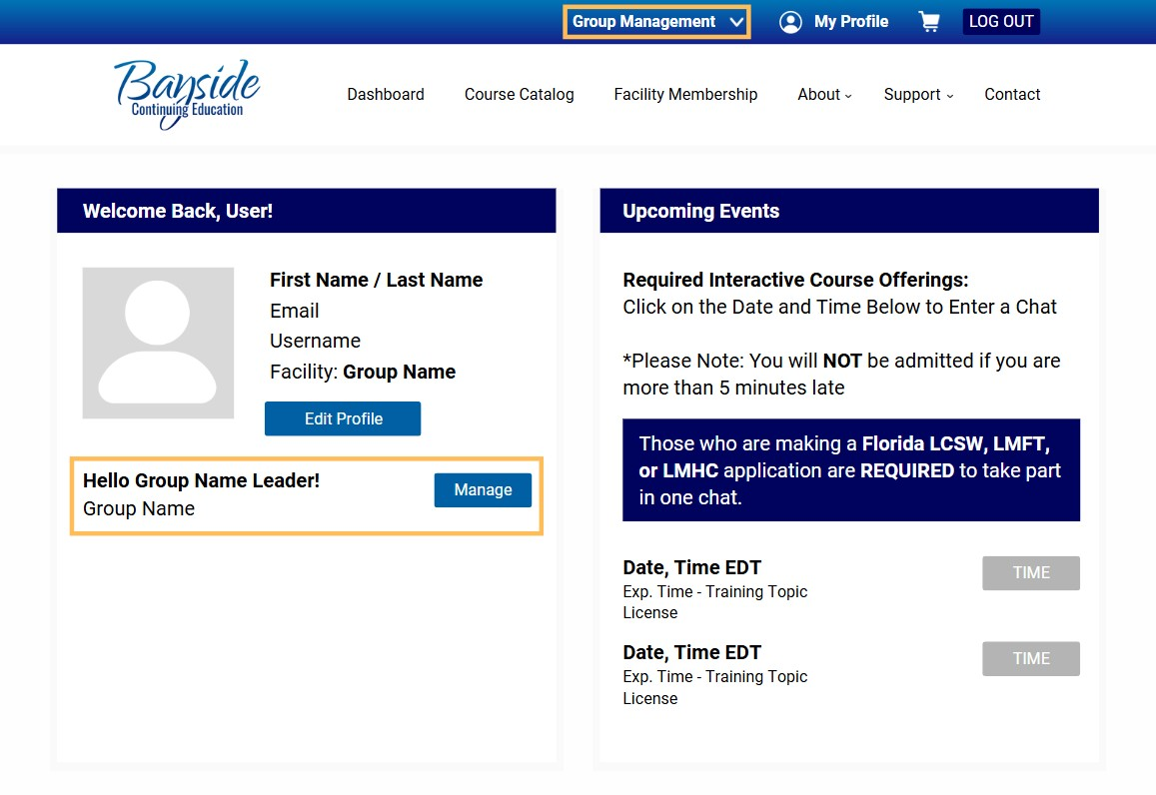

Onboarding Employees

Step 1 – Open the Employee & Group Leader Rosters
From the Group Management Dashboard, click Group Management. You will see two tables:
- Employee Roster / Enrolled Users – All users using a seat in your Facility Group.

  - First Name, Last Name, Email, Status, and Key are displayed.

  - Status Options:
■ Not Enrolled – Invited but not enrolled in the group.
■ Not Started – Enrolled but has not started any courses.
■ In Progress – Enrolled and has started taking courses.

  - Key: A unique access key is created for each user when invited. This key enrolls them in the group.

- Group Leader Roster – All users with Group Leader access. Add or Remove from this table.

Step 2 – Add a New Employee
1. Click the Manage (Users) dropdown above the Employee Roster and select Add One.
If the employee already has a BaysideCEU account:
- Enter the email they used to create their account, first name, and last name.
- They will receive an email with their Individual Access Key.
- Instruct them to log in, go to Edit Profile on the Dashboard page, and enter the key in the Partner Access section.
If the employee does not have a BaysideCEU account:
- Enter their email, first name, and last name they will use for their account.
- They will receive an email with their Individual Access Key and a link to create an account.
- The link will auto-fill the key in the account creation form.
- Once their account is created with the key entered, they are automatically enrolled in your group.
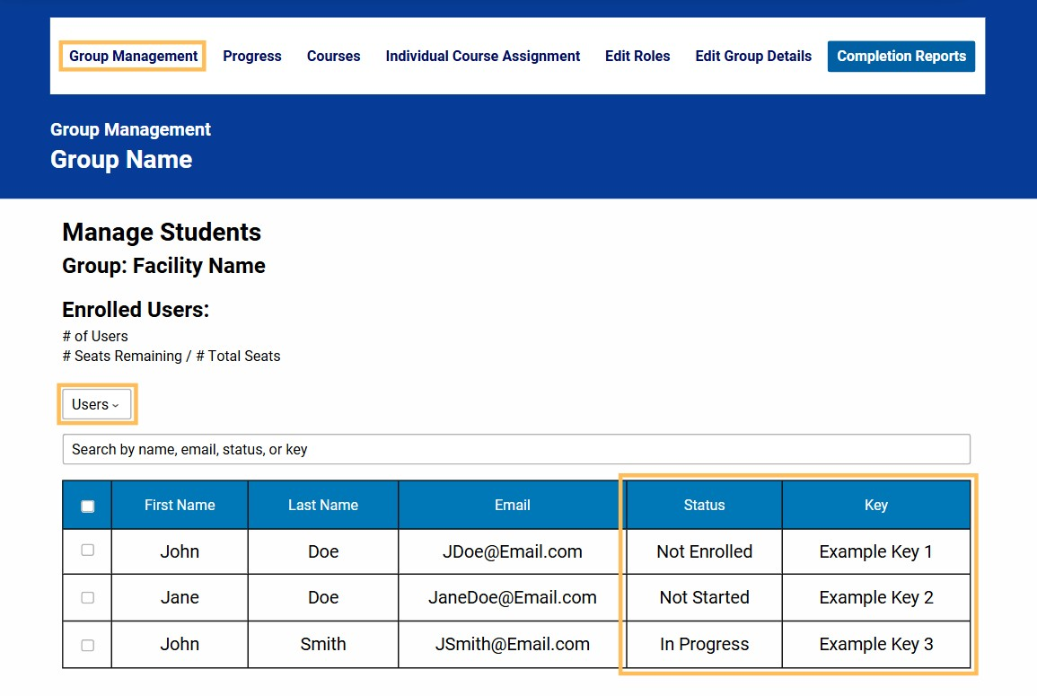

Assigning Courses & Roles
There are two ways to assign courses:

Option 1 – Assign Courses to an Individual
- From the Group Management Dashboard menu, select Individual Course Assignment under the Compliance tab.
- Enter the employee’s name in the Select a User field.
- Search for and select the courses you want to assign.
Click Save Changes.

Option 2 – Assign Courses by Role
- From the Group Management Dashboard menu, select Edit Roles under the Compliance tab.
- Enter the name of the role (e.g., “Counselor,” “Nurse,” “Direct Care Staff”).
- Search for and select courses for that role.
- Click Save Changes.
The roles appear as drop-down menus containing all assigned courses. This is accessible under each enrolled users Dashboard tab with the name Group Name Assigned Courses:
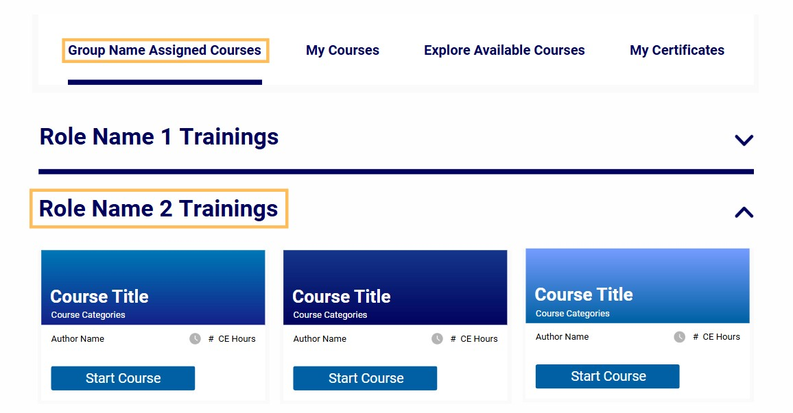

Tracking Progress & Completions

View Course Progress
From the dashboard menu, click Progress.
Filter the table as needed to view:
- Courses taken
- Courses in progress
- Courses not started
Using this tab, you can see: Courses your employees have taken, have progressed in, and have not started

View Completion Reports & Download Certificates
- From the dashboard menu, click Completion Reports.

This page will display all course completions of the employees enrolled in your group.

- Filter by name, course, facility group, or date.
- Download certificates by either:

  - Clicking the Checkbox in the far-left column of the table, then clicking Print/Download Certificates

  - Clicking the Certificate Icon in the far-right column of the table
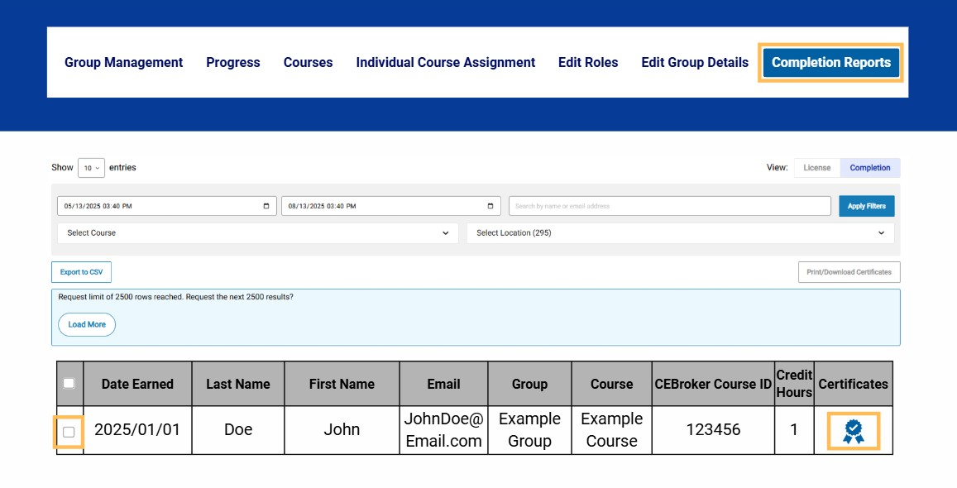

Account Settings & Support

Update Facility Information
From the Group Management Dashboard, click Edit Group Details, input your needed changes and select Save Changes Need Help?
- Email Support: ContactUs@baysideceu.com
- Text Support: (407) 264-9800

You’re Ready to Go!
That’s it — you now have everything you need to manage your facility’s training with BaysideCEU. From onboarding staff to assigning courses, tracking progress, and printing certificates, you should feel confident navigating the system and keeping your team compliant year-round.
Thank you for choosing BaysideCEU as your training partner. We’re proud to support your facility’s mission and look forward to helping you keep compliance simple, fast, and reliable.

